**Project - Phase III: Dashboard Implementation**

Harsh Anand

Navya Akshitha Sangishetty

Nikitha Kakuru

Sampath Kumar Kuram

Department of Information Technology, Arizona State University

IFT 598 Data Visualization & Reporting for IT

Asmaa Elbadrawy

November 27, 2022

**Section 1: The Dashboard**

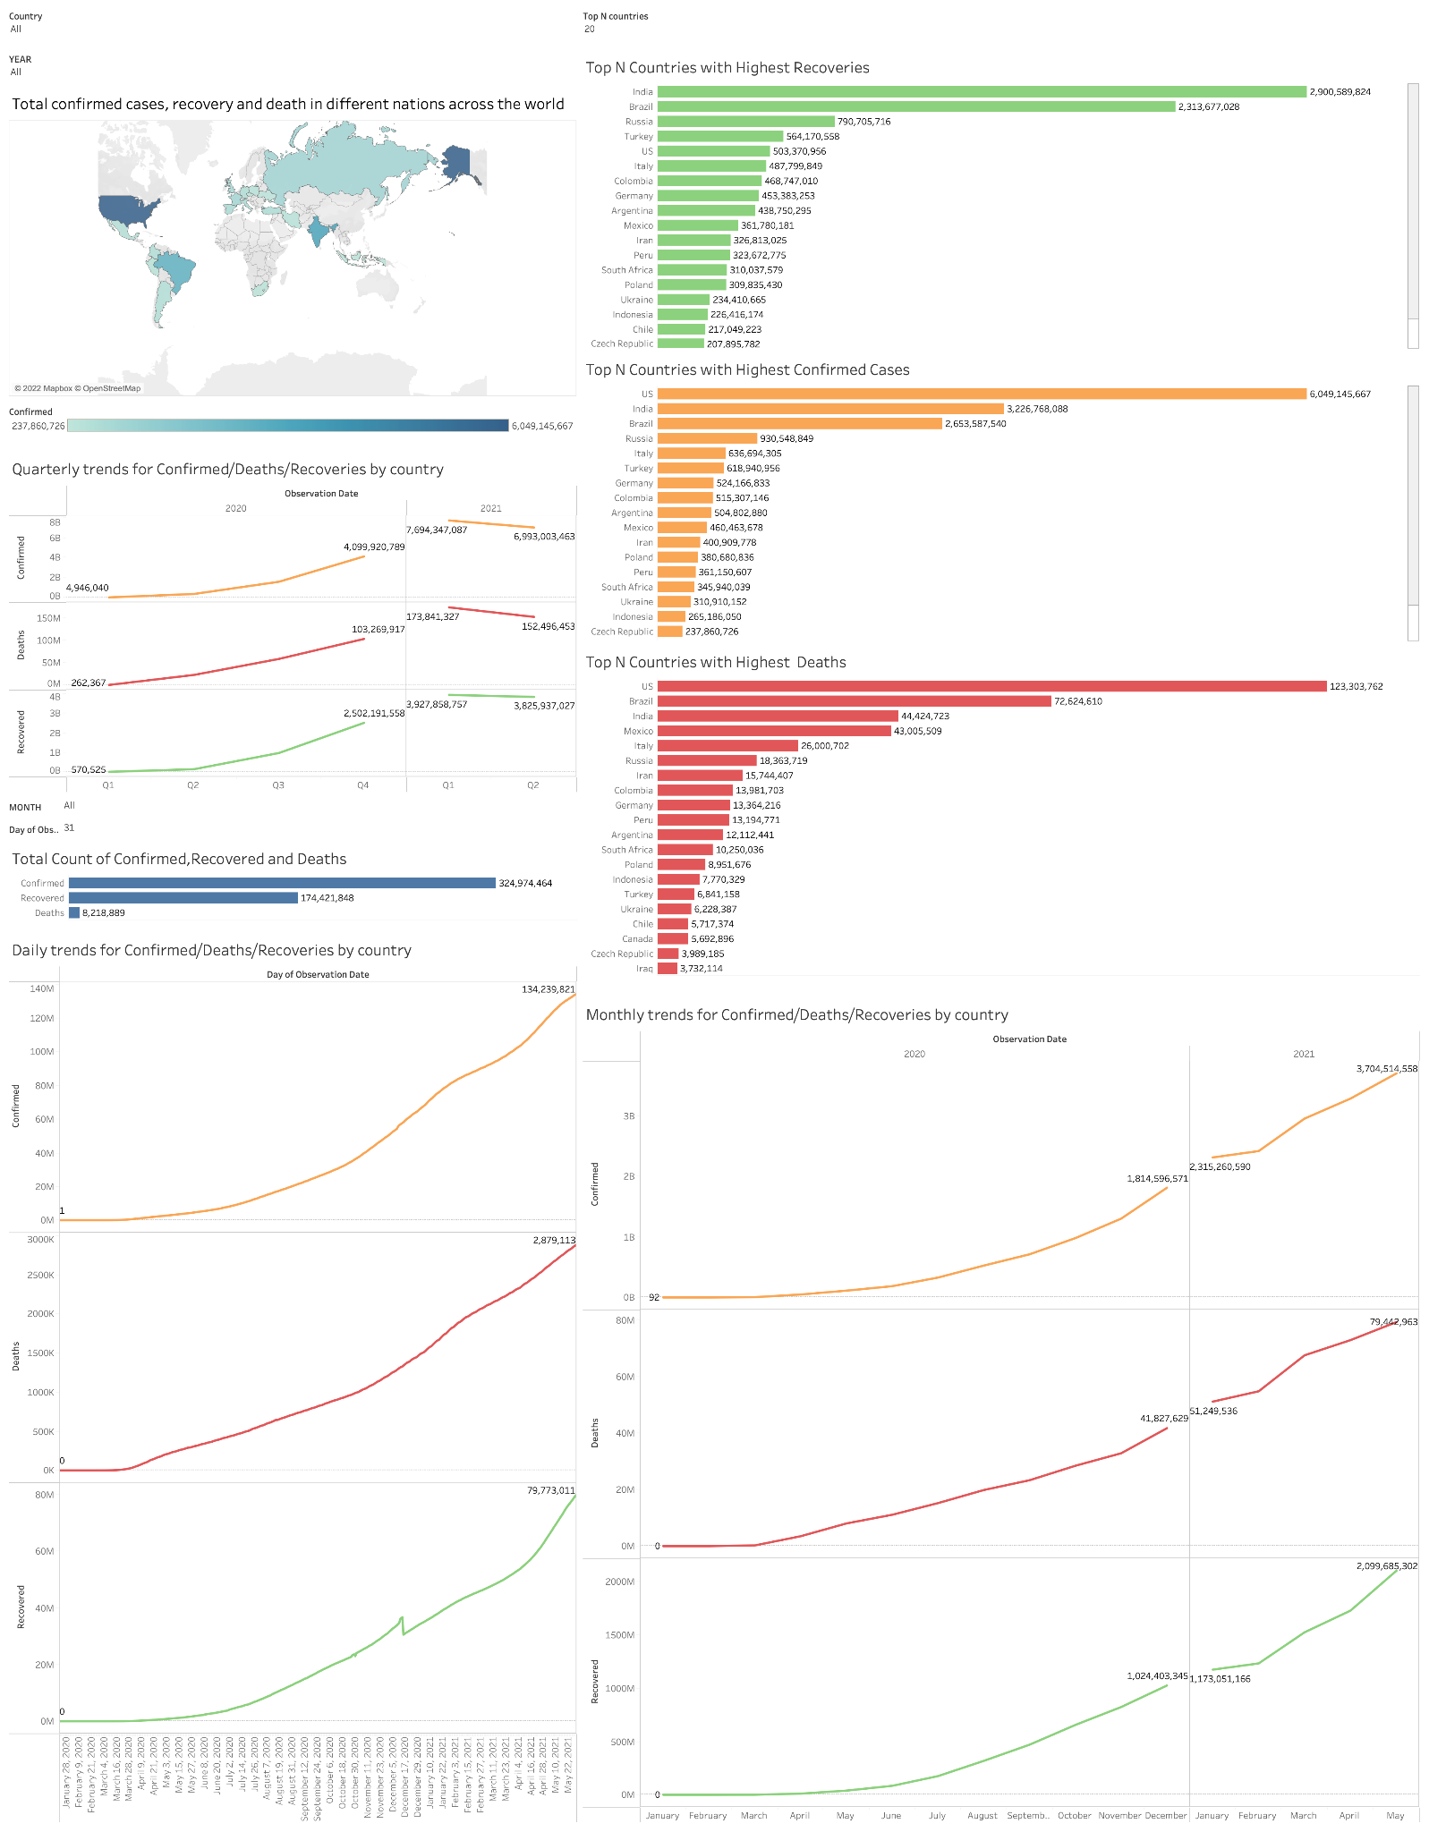

The dashboard displays the COVID-19 trends daily, monthly, and quarterly for confirmed cases, recovered cases, and deaths in various nations around the world. In order to set priorities and take prompt, decisive action in response to rapidly shifting COVID-19 situations, the government, health services, the general public, and many other sectors can all use the dashboard.

### **Section 2: The Dataset**

**Dataset Description:** The dataset on which we will be working in this project is the "Novel Corona Virus 2019 Dataset," in which the World Health Organization expressed alarm about a new virus that has yet to be discovered and how it affects humans. When daily-level information on the afflicted people is made available to the larger data science community, it can provide some fascinating insights.

This dataset contains daily statistics on the number of impacted patients, fatalities, and recovery from the 2019 coronavirus. Thus, the number of instances on any given day represents the total number of cases.

The dataset contains the following Attributes/Columns:

● Observation Date MM/DD/YYYY - The observation showcases the number of covid cases reported daily.

Datatype: Interval

Domain: Range (01/22/2020 to 05/29/2021)

● Province/State – It showcases the names of provinces or states of different countries which are considered for observation in which few can be empty when there is missing data.

Datatype: Categorical

Domain: List (input is from the Province/State column)

● Country/Region - This column contains the names of the countries considered for observation.

Datatype: Categorical

Domain: List (input is from the Country/Region column)

● Confirmed – This column provides the cumulative number of confirmed cases of COVID - 19 till the date of the last observation conducted.

Datatype: Ratio

Domain: List (input is from the Confirmed column)

● Deaths - This column provides the cumulative number of deaths due to COVID-19 up to the date of the last observation conducted.

Datatype: Ratio

Domain: List (input is from the Deaths column)

● Recovered - This column provides the cumulative number of recovered cases of COVID - 19 till the date of the last observation conducted.

Datatype: Ratio

Domain: List(input is from the Recovered column)

● Longitude - it contains the longitudinal geographical location countries of confirmed, recovered, and death numbers.

Datatype: Interval

Domain: List(input is from the Longitude column)

● Latitude - it contains the latitudinal geographical location of confirmed, recovered, and death numbers.

Datatype: Interval

Domain: List(input is from the Longitude column)

* No pre-processing required for our dataset.

### **Section 3: Dashboard Users**

● **Government**

The government relies heavily on data for decision-making and action to combat the COVID-19 pandemic. These data enable the government to set priorities and make quick and effective decisions in response to rapidly changing COVID-19 situations.

● **Health Services**

The dashboard will let physicians efficiently assess patient volumes and case severity in order to prioritize clinical care and allocate scarce resources more effectively.

● **General Public**

The dashboard provides everyone, from business and government leaders to the public, with the information they need to make informed decisions.

**Section 4: Questions**

1. Daily trends of the total number of Covid Confirmed cases by Countries.

2. Daily trends of the total number of Covid Recoveries by Countries.

3. Daily trends of the total number of Covid Deaths by Countries.

4. Monthly trends of the total number of Covid Confirmed cases by Countries.

5. Monthly trends of the total number of Covid Recoveries by Countries.

6. Monthly trends of the total number of Covid Deaths by Countries.

7. Quarterly trends of the total number of Covid Confirmed cases by Countries.

8. Quarterly trends of the total number of Covid Recoveries by Countries.

9. Quarterly trends of the total number of Covid Deaths by Countries.

10. Trends showing Daily cases, Recoveries, and Deaths by Countries.

11. Trends showing Monthly cases, Recoveries, and Deaths by Countries.

12. Trend showing Quarterly cases, Recoveries, and Deaths by Countries.

13. Total Confirmed cases, Recoveries, and Deaths in different nations across the world.

14. Total number of Confirmed, Recoveries and Deaths per year/month/day.

15. Top N Countries/states with the highest Covid Confirmed cases.

16. Top N Countries/states with the highest number of Covid Recoveries.

17. Top N Countries/states with the highest number of Covid Deaths.

**Section 5: Plots**

**Question 1:**

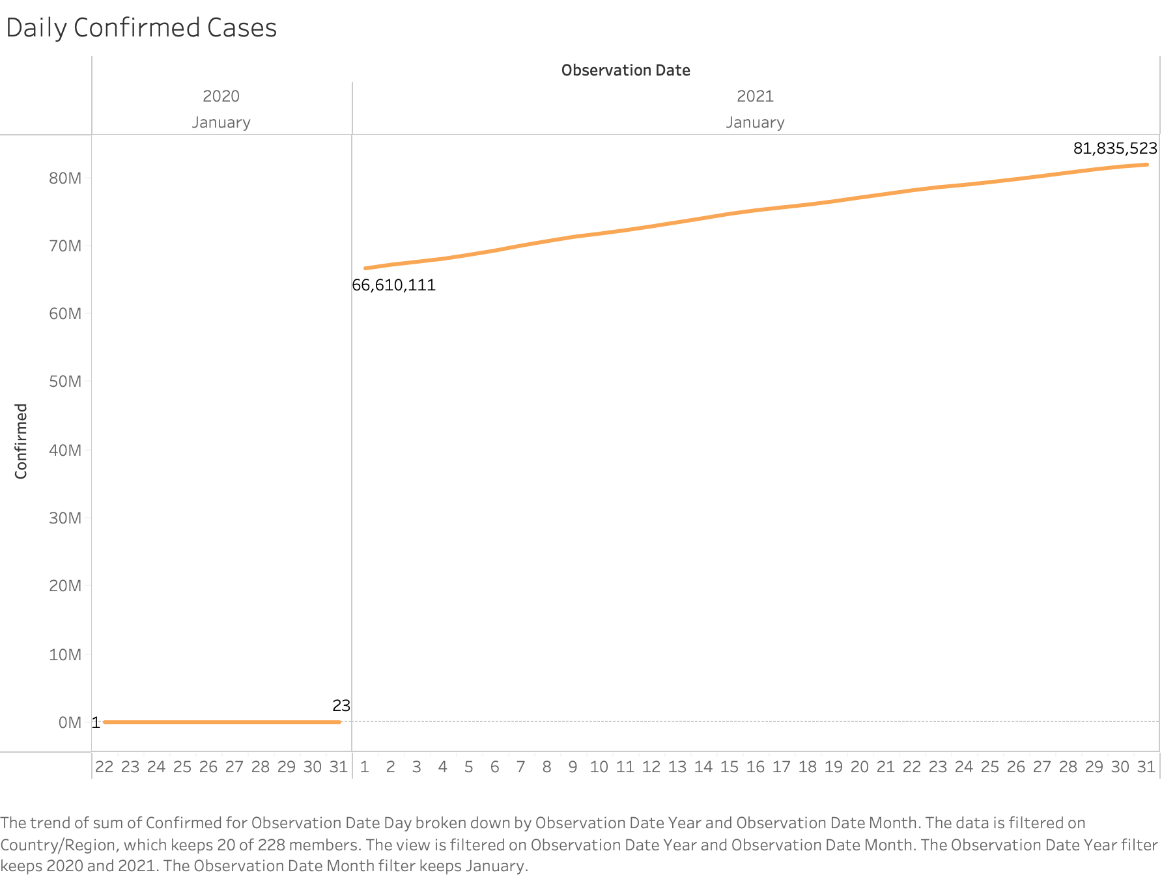

This graph provides an answer to the question, "Daily trends of the total number of Covid Confirmed cases by Countries."

**Explanation**: This visualization depicts the cumulative number of covid cases confirmed in different countries on a daily basis. The user can filter this plot by country, month, and year. Pre-Attentive Attribute used is Color i.e. Orange for Confirmed cases.

**Question 2:**  
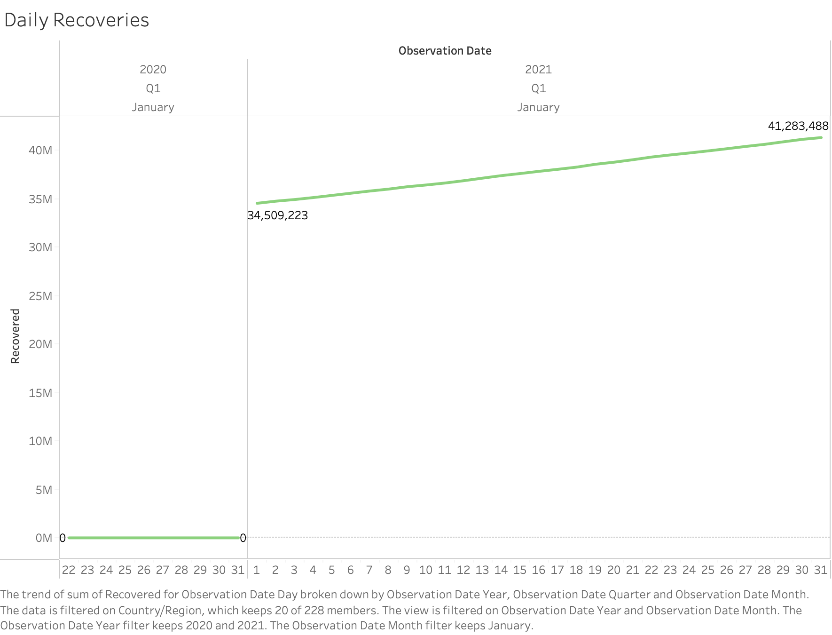

This graph provides an answer to the question, "Daily trends of the total number of Covid Recoveries by Countries."

**Explanation**: This visualization depicts the cumulative number of covid recovered cases in different countries on a daily basis. The user can filter this plot by country, month, and year. Pre-Attentive Attribute used is Color i.e. Green for Recoveries.

**Question 3:**

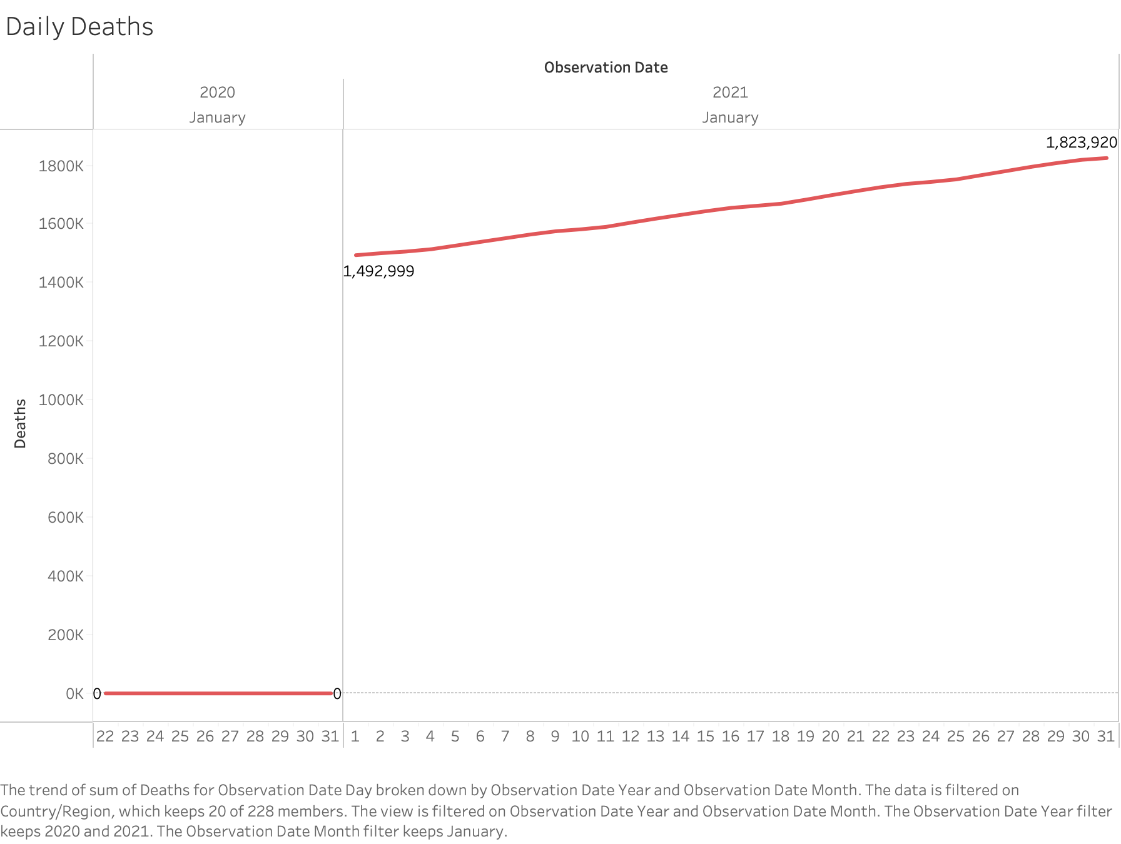

This graph provides an answer to the question, "Daily trends of the total number of Covid Deaths by Countries."

This visualization depicts the cumulative number of covid death cases in different countries on a daily basis. The user can filter this plot by country, month, and year. Pre-Attentive Attribute used is Color i.e. Red for Deaths.

**Question 4:**

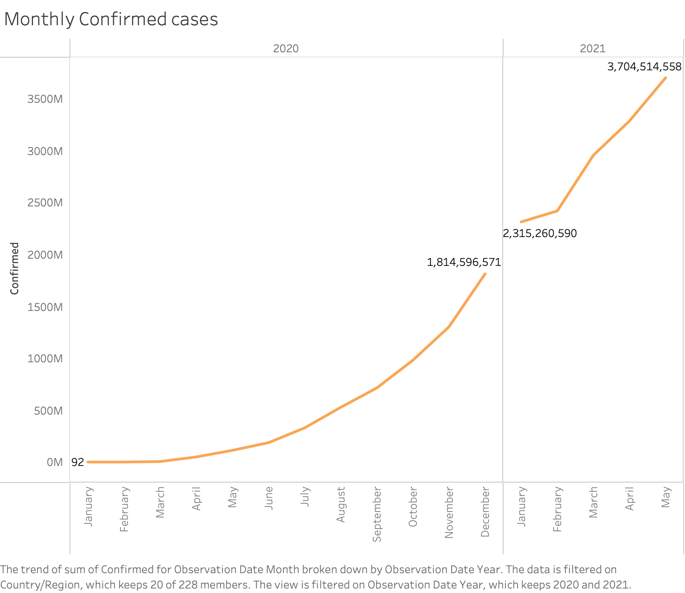

This Plot answers the question “Monthly trends of the total number of Covid Confirmed cases by Countries.”

**Explanation**: To maintain the minimum data-ink ratio, we used line graph to visualize the trend of sum of the number of Covid-19 confirmed cases for Observation Date by month starting from January-2020 to May-2021. We’ve used Country, year filters for user interaction. Pre-Attentive Attribute used is Color i.e. Orange for Confirmed Cases.

**Question 5:**

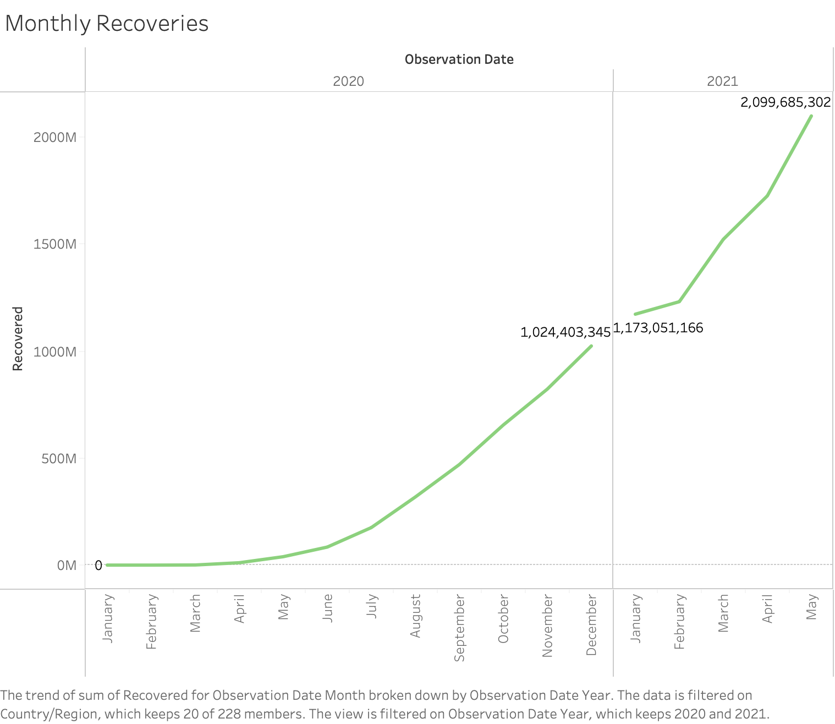

This Plot answers the question “Monthly trends of the total number of Covid Recoveries by Countries.”

**Explanation**: To maintain the minimum data-ink ratio, we chose line graph to visualize the trend of sum of Covid Recoveries for Observation Date by month starting from January-2020 to May-2021. We’ve used Country, year filters for user interaction. Pre-Attentive Attribute used is Color i.e. green for Recoveries.

**Question 6:**

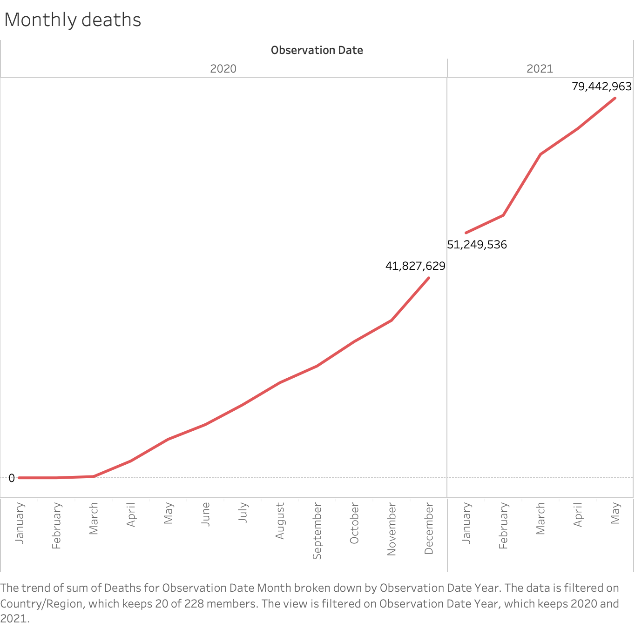

This Plot answers the question “Monthly trends of the total number of Covid Deaths by Countries.”

**Explanation**: To maintain the minimum data-ink ratio, we chose line graph to visualize the trend of sum of Covid Deaths for Observation Date by month starting from January-2020 to May-2021. We’ve used Country, year filter for user interaction. Pre-Attentive Attribute used is Color i.e. Red for Deaths.

**Question 7:**

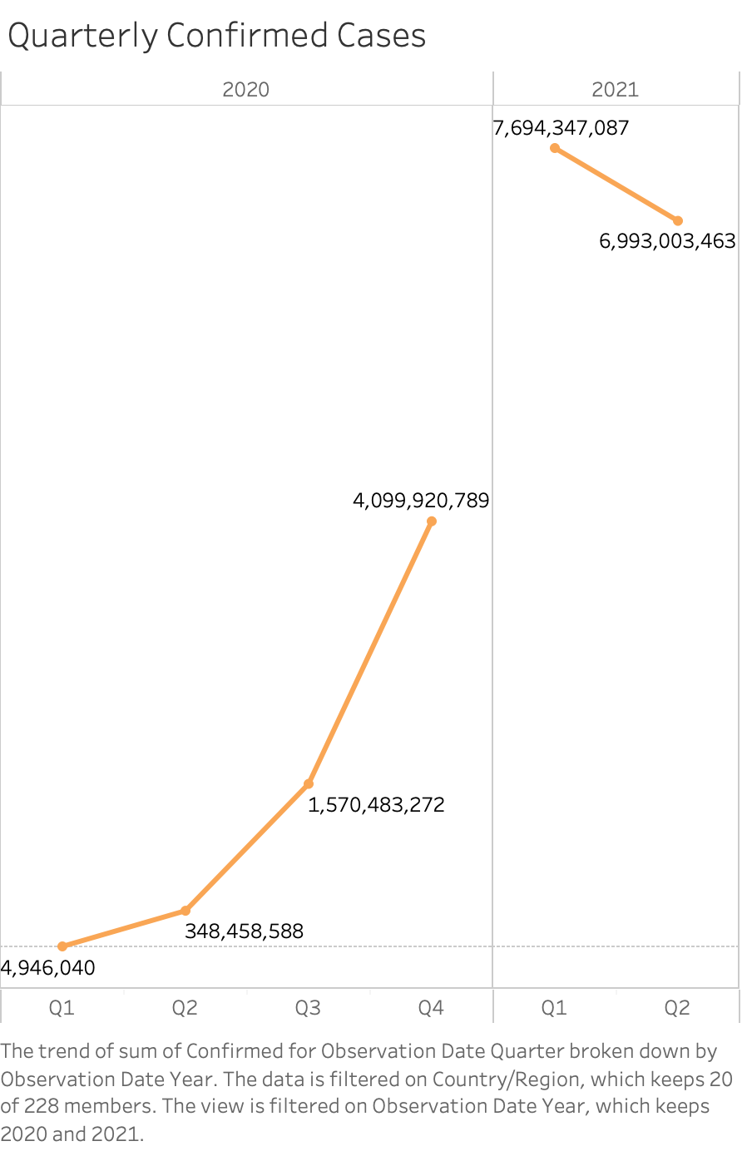

This Plot answers the question “Quarterly trends of the total number of Covid Confirmed cases by Countries.”

**Explanation**: We used Line graph to visualize the quarterly trends of sum of confirmed cases by country ​​starting from Quarter 1 2020 till Quarter 2 2021 by using Countries, Year filters which creates user interaction. Pre-attentive attribute used is Color. We used Orange color for Confirmed Covid Cases.

**Question 8:**

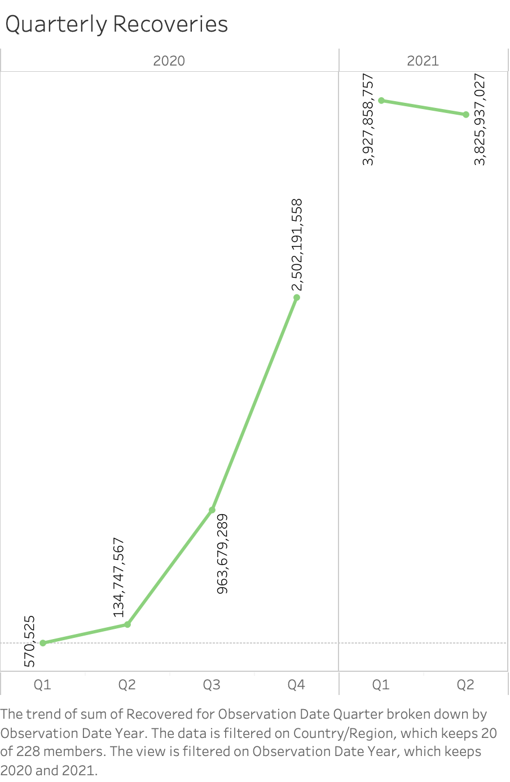

This Plot answers the question “Quarterly trends of the total number of Covid Recoveries by Countries.”

**Explanation**: We used Line graph to visualize the quarterly trends of sum of recoveries by country ​​starting from Quarter 1 2020 till Quarter 2 2021 by using Countries, Year filters which creates user interaction. Pre-attentive attribute used is Color. We used Green color for Covid Recoveries.

**Question 9:**

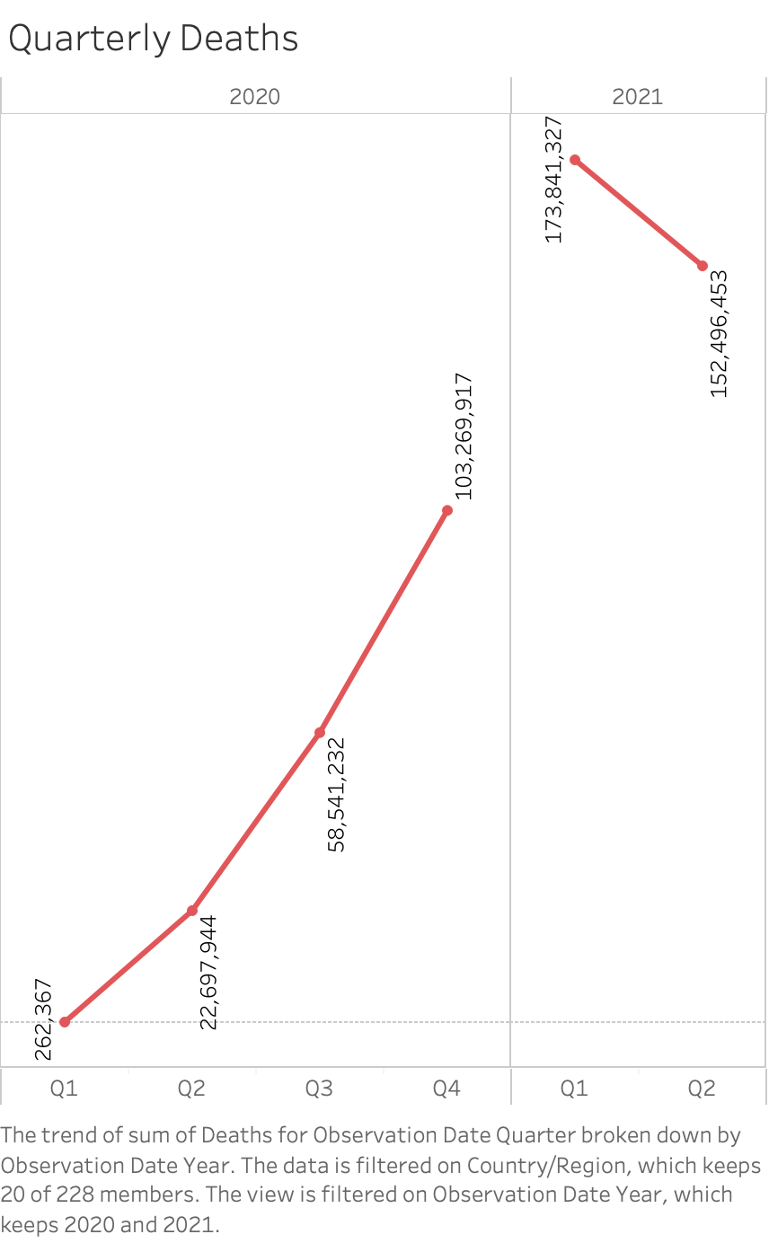

This Plot answers the question “Quarterly trends of the total number of covid deaths by countries.”

**Explanation**: We used Line graph to visualize the quarterly trends of sum of Covid deaths by country ​​starting from Quarter 1 2020 till Quarter 2 2021 by using Countries, Year filters which creates user interaction. Pre-attentive attribute used is Color. We used Red color for Covid Deaths.

**Question 10:**

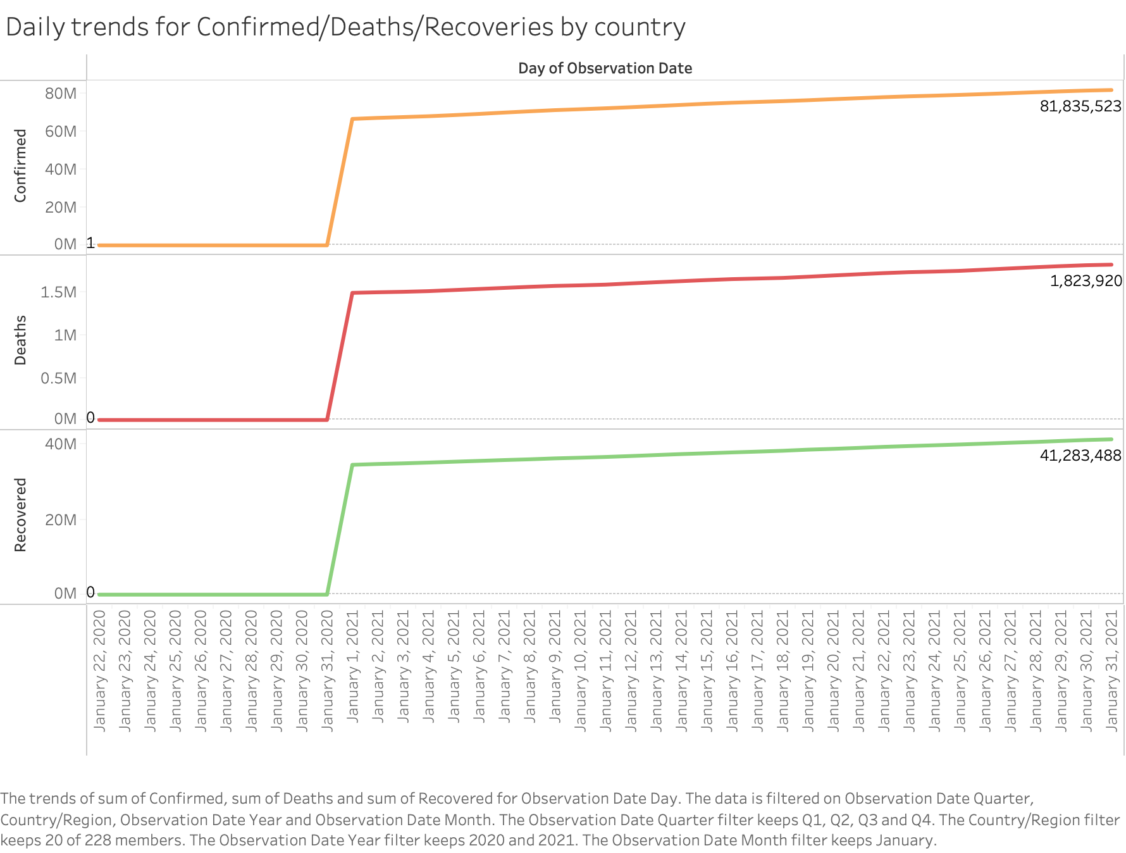

This Plot answers the question “Trends showing Daily Confirmed cases, Recoveries, and Deaths by Countries.” This visualization is used to showcase the daily trends of all the confirmed cases, deaths and recoveries by country ​​starting from January-2020 till May-2021. We used Country, Year and Month filters which enables user interaction. We also used different colors like Orange for confirmed cases, Red for death cases, and Green for recoveries.

**Question 11:**

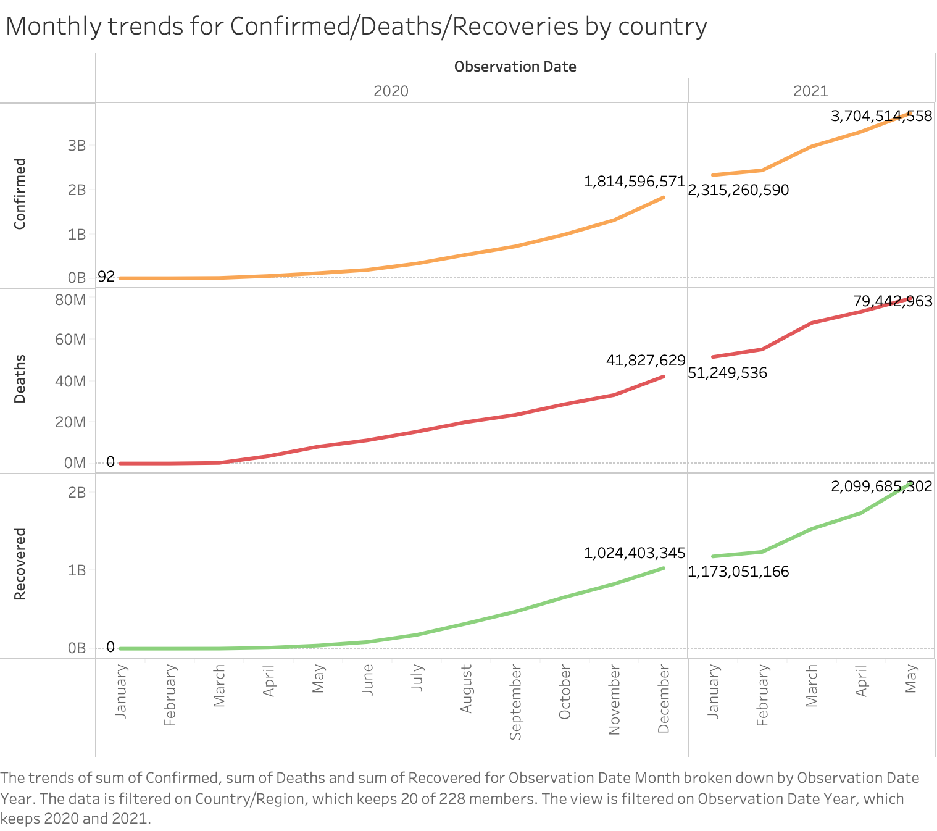

This Plot answers the question “Trend showing Monthly Cases, Recoveries, and Deaths by Countries”

**Explanation**: This visualization is used to showcase the monthly trends of all the confirmed cases, deaths and recoveries by country ​​starting from January-2020 till May-2021. We used Country, Year filters which enables user interaction. We also used different colors like Orange for confirmed cases, Red for death cases, and Green for recoveries.

**Question 12:**

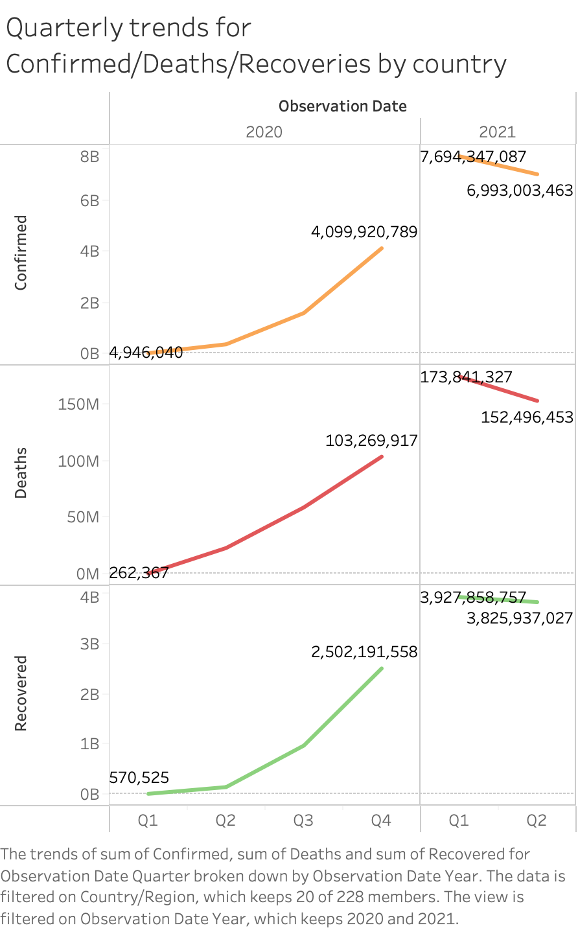

This Plot answers the question “Trend showing Quarterly Cases, Recoveries, and Death by Countries.

**Explanation**: This visualization is drawn using a line graph, to showcase the quarterly trends of all the confirmed cases, deaths and recoveries by country ​​starting from Quarter 1 2020 till Quarter 2 2021. We used Country, Year, Quarter filters which create user interaction and also used colors like Orange for Confirmed, Red for Deaths and Green for Recoveries.

**Question 13:**

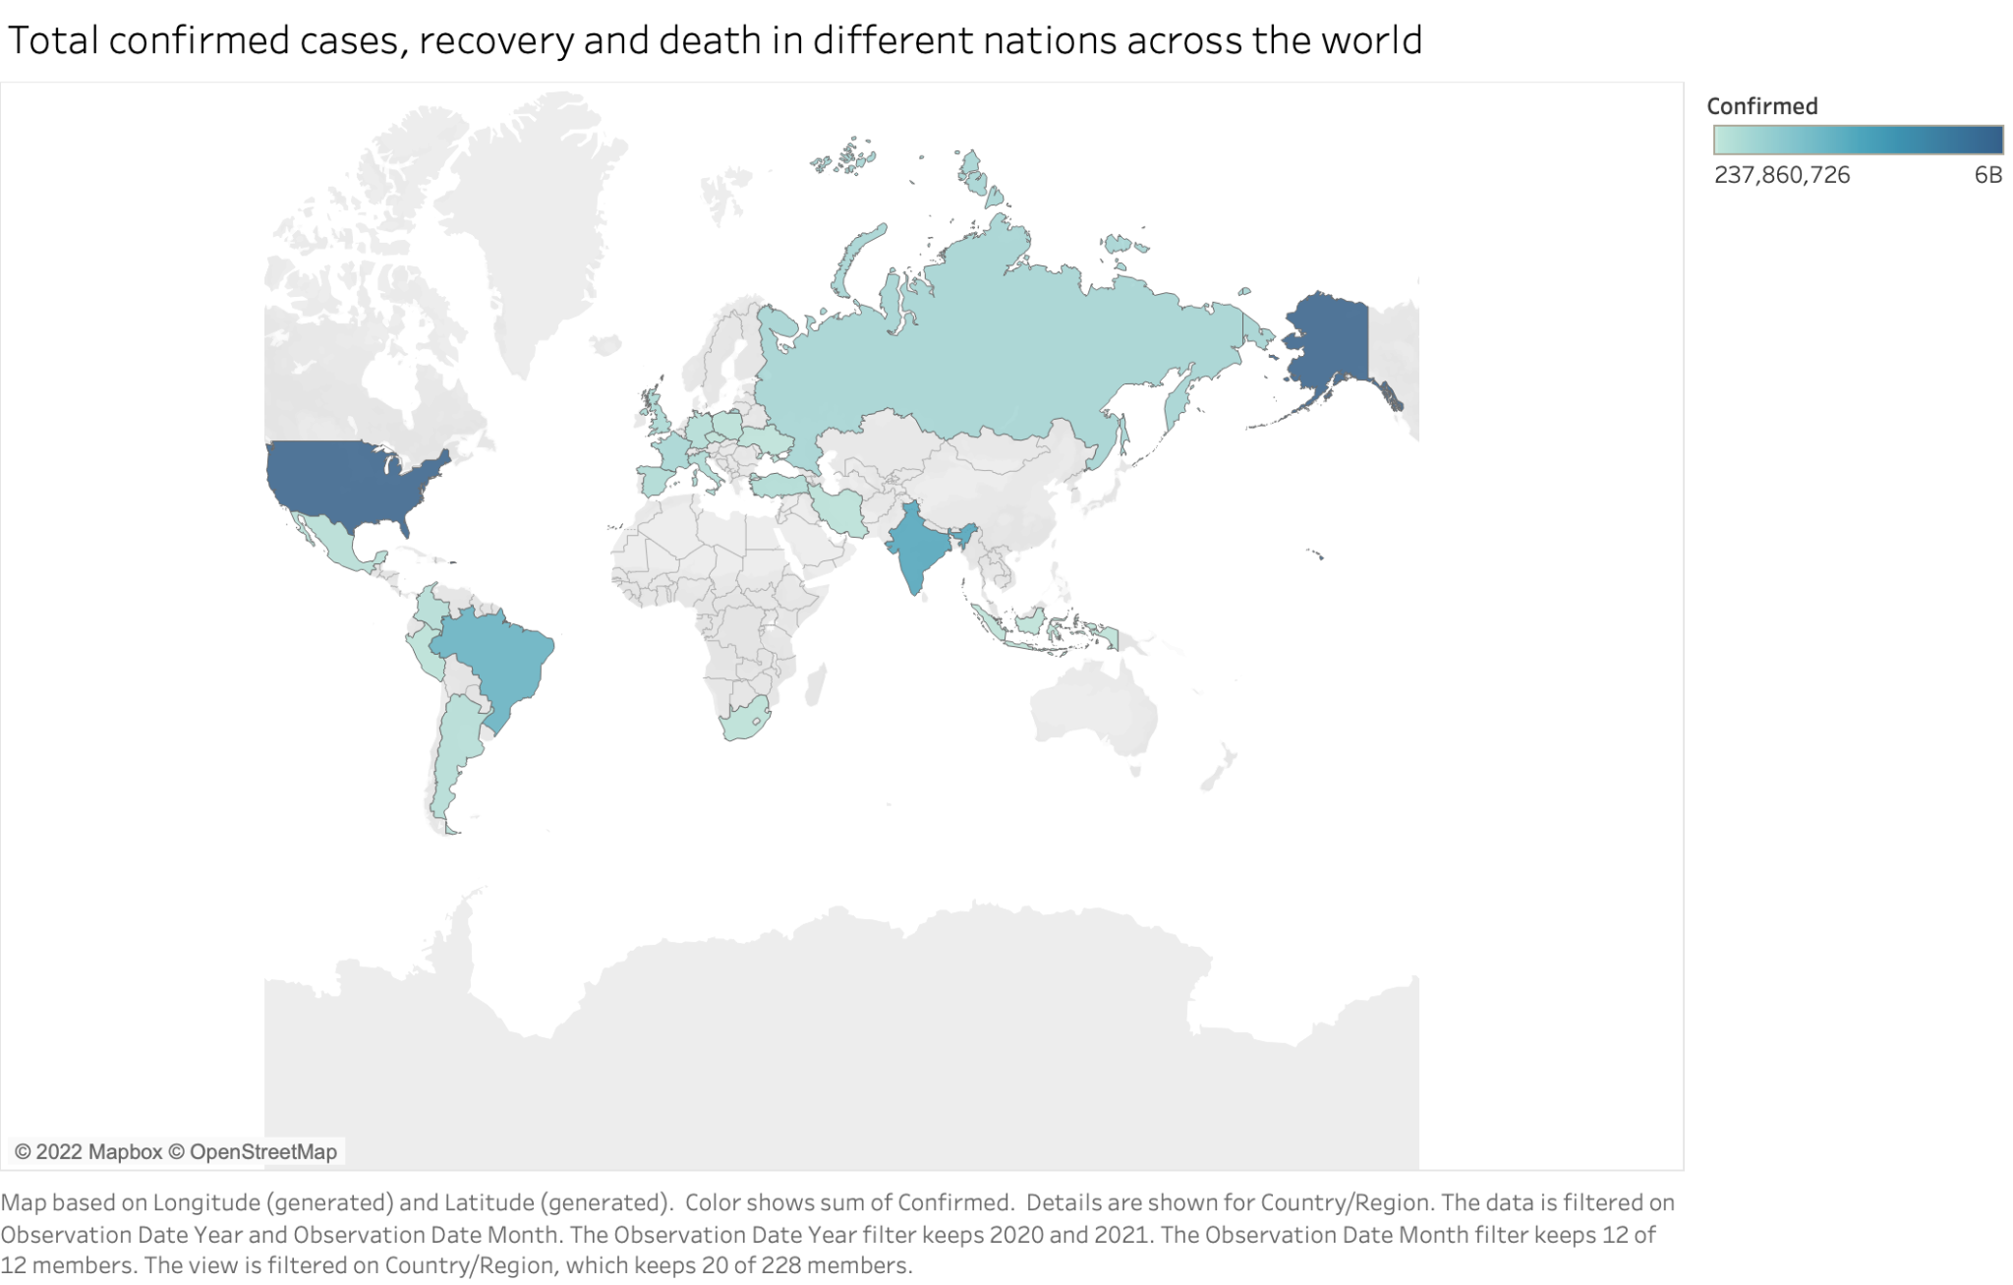

This graph provides an answer to the question, "Total confirmed cases, recovery, and deaths in different nations across the world?"

**Explanation**: This visualization represents the distribution of confirmed, recovered cases and death across the countries. The user can use the countries, month, and year filters to interact with the visualization.

**Question 14:**

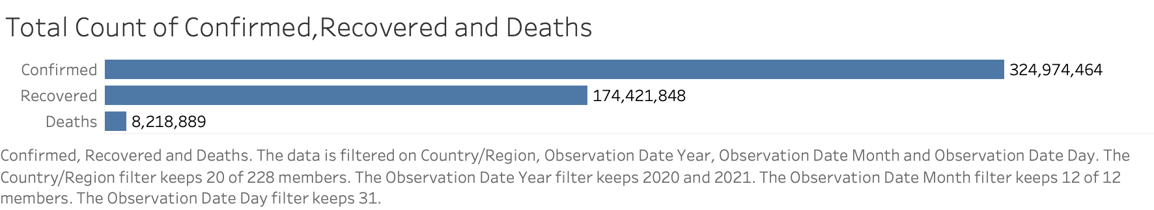

This plot answers the question “Total number of Confirmed, Recoveries and Deaths per year/month/day.”

**Explanation**: Here the bar graph shows the total number of confirmed cases, deaths, and recoveries using filters for Country, Year, Month, and Day for user interaction. Pre- attentive attributes used are color, length.

**Question 15:**

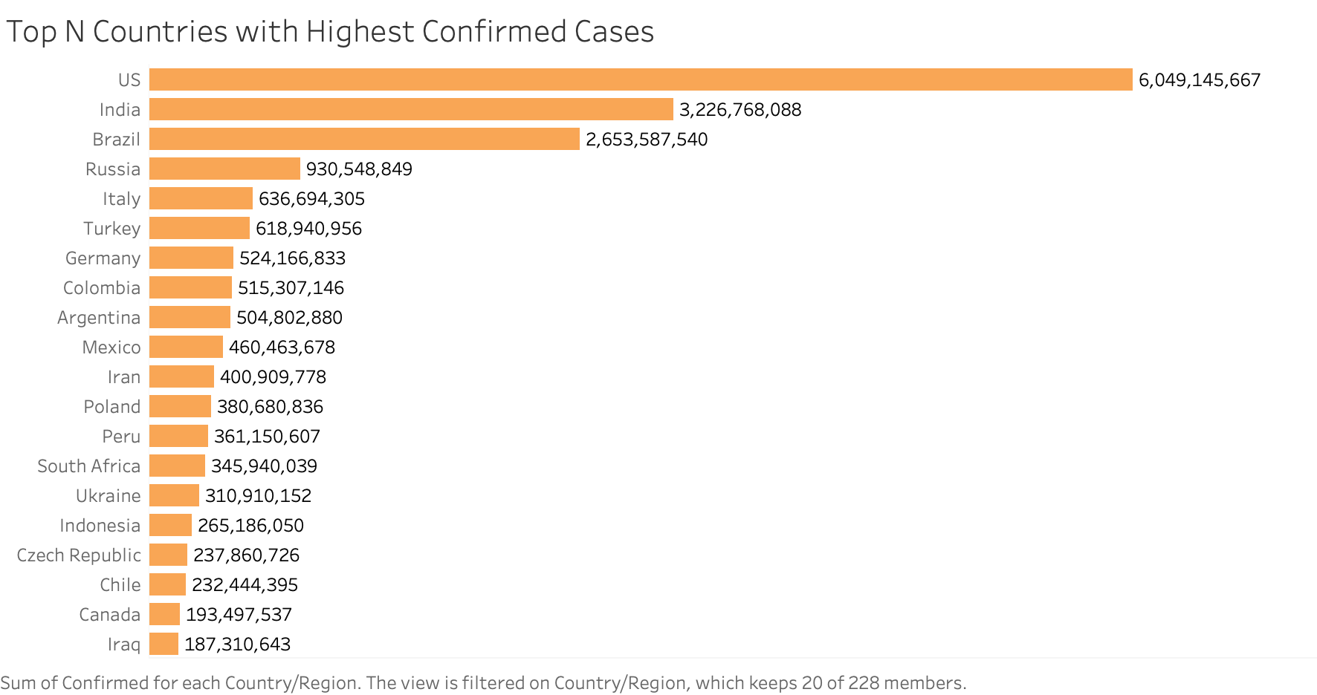

This graph provides an answer to the question, "Top N Countries/states with the highest number of confirmed cases?"

This visualization represents the TOP N countries with the highest confirmed cases. The user can interact with this visualization by providing TOP N value and this visualization will change according to the input provided. Pre- attentive attributes used is length, color i.e. Orange for Confirmed Cases.

**Question 16:**

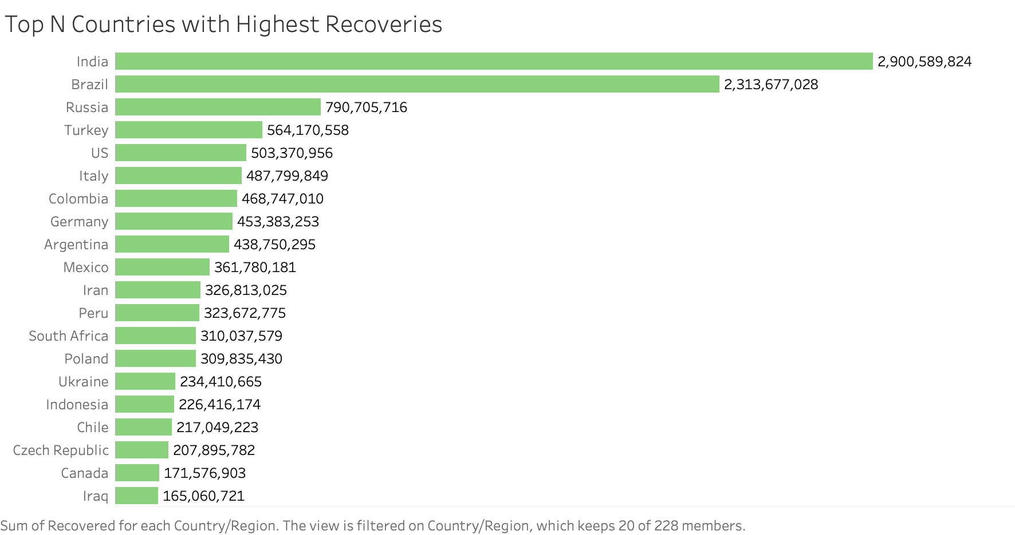

This graph provides an answer to the question, "Top N Countries/states with the highest number of recoveries?"

This visualization represents the TOP N countries with the highest number of recoveries. The user can interact with this visualization by providing TOP N value and this visualization will change according to the input provided. Pre- attentive attributes used is length, color i.e. Green for Recoveries.

**Question 17:**

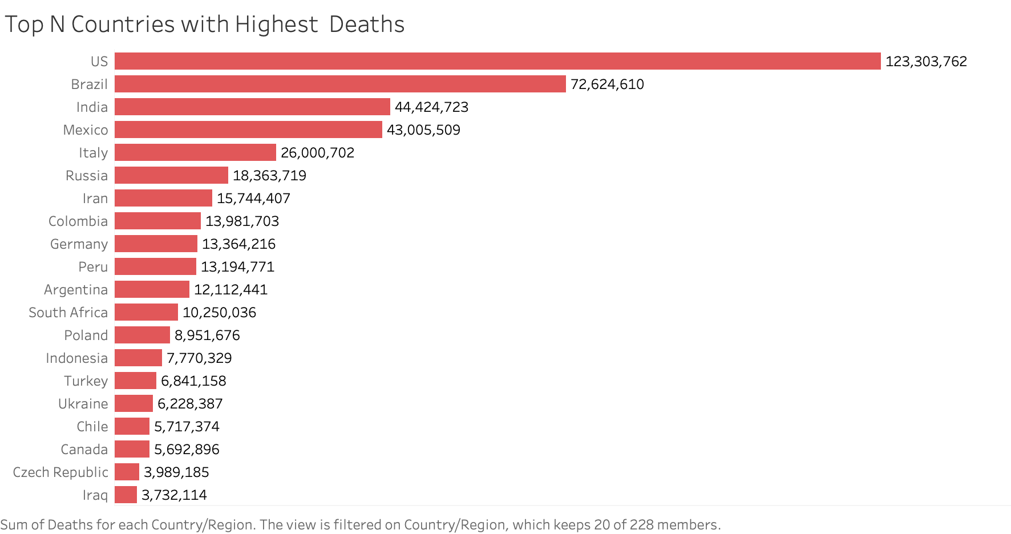

This graph provides an answer to the question, "Top N Countries/states with the highest number of deaths?"

This visualization represents the TOP N countries with the highest deaths. The user can interact with this visualization by providing TOP N value and this visualization will change according to the input provided. Pre- attentive attributes used is length, color i.e. Red for Covid Deaths.

**Section 6: Interactivity**

In question 1,2,3 we are using Top n filter in which the user will put a inter value and based on the value the chart will change and show the Top N countries with highest number of confirmed, recoveries and death.

In question 4,5,6,7,8,9 we are going to add Month, year and country filter. So the user can see the daily trends by selecting month, year and country from the drop down.

In question 10,11,12 we are putting country filter so the user can see monthly trends by country.

In question 13 the cloropath map will change based on Month, year and country filter.

In question 14,15,16 and 17 we are putting Month and Year filter.

**REFERENCES**

**Mural Link**

https://app.mural.co/t/team55769/m/team55769/1668114250029/2153fa6b771d48cf7e7c5c0be7709a9c7eadabef?sender=ucaba08cce9c57a8852bd7940

**Dataset**

<https://www.kaggle.com/datasets/sudalairajkumar/novel-corona-virus-2019-dataset>

**Dashboard Link**

<https://public.tableau.com/shared/RZPWK4FGP?:display_count=n&:origin=viz_share_link>